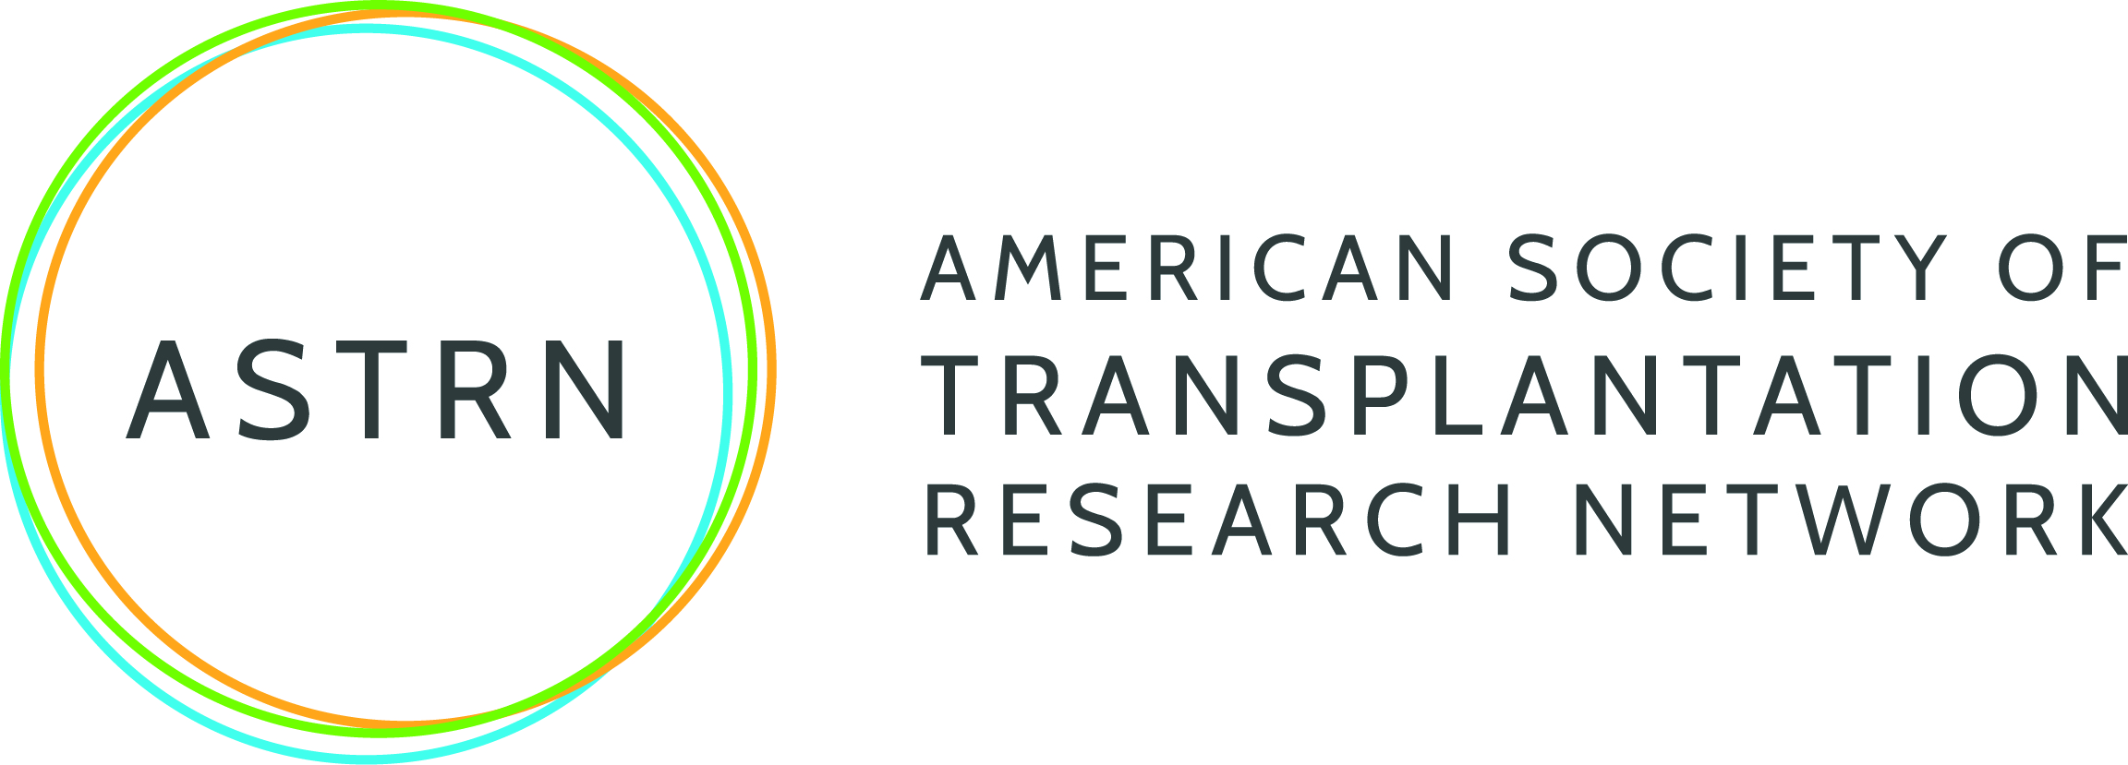
Travel for Techniques in Transplantation Research (T³R)

to promote lab-to-lab partnerships in transplantation science
Application Directions
Read the AST T3R Request for Application before completing for full details.
Complete the application in its entirety. Attach the applicant biosketch and the host PI biosketch at the end of this application. Then combine all documents into one PDF document and submit via email to research@myast.org.
APPLICANT INFORMATION
Name
Title
Institution
Department
Street Address
City, ST, Zip
Phone
Email Address
AST Member? | Yes No
Will you be traveling or assigning the award to another lab member? |  | I am traveling  Awarding to another member

TRAVELER INFORMATION (if not applicant)
Name
Title
Phone
Email Address

HOST PI INFORMATION
Name
Title
Institution
Department
Street Address
City |  | ST/ Province |  | Postal Code
Phone
Email Address

TRAVEL AND TECHNIQUE INFORMATION
Dates of Visit
Technique Name
Is the technique currently available at the applicant’s institution? |  | Yes No

Explain the reason you are traveling to the host PI’s particular lab. (If the applicant institution has the technique, the applicant must also address the reason to travel.)
Open-ended (750 characters)

Describe the technique to be learned.
Open-ended (1,000 characters)

Describe the relevance of the technique to solid organ transplantation.
Open-ended (250 characters)

Describe how and why the technique will benefit your research program. Include the feasibility to apply the learned technique.
Open-ended (2,000 characters)

Append the following documents to the end of this application:
- Applicant biosketch
- Host PI biosketch

