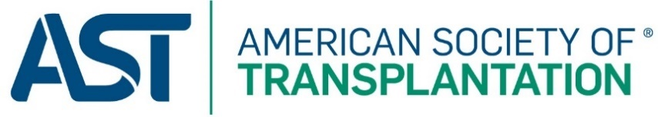
Innovation award
Program/project details
The AST Innovation Award is open to the entire transplant community.
The types of innovation that would be eligible for this award include but are not limited to breakthroughs in research; novel programs implemented by hospitals, insurance companies, OPOs, patient groups, pharmaceutical companies, or professional organizations.
Eligibility Criteria
1. The innovation does not need to occur within the year of nomination.
2. Individuals, groups, and companies may apply.
3. AST membership is not a requirement for this award.

Complete this Program/Project Details and upload the document on the online Innovation Award application found at www.myast.org/innovation-award.

Program / project title
Provide the title of the Program/Project

background
Provide the background of the Program/Project

completed work
Provide a summary of the work completed

results
Provide the results of the Program/Project

publications and presentations
Provide any publications or presentations on the Program/Project (not required)

