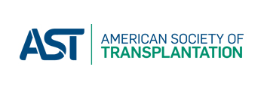
Request for AST endorsement of an educational activity
Payment form for endorsement request fee

Title of activity:
Activity contact:
Date of endorsement request: DATE, YR
Amount of nonrefundable endorsement request fee: $250.00 USD

Please complete credit card information and return this form by fax (856-581-9604) or by mail. Do not scan/email this document as that is not a secure method of transferring credit card information.

Name on card:

Card #:

Expiration Date:

Signature:

Billing Address 1:

Billing Address 2:

Billing City and State:

Billing Zip/Postal Code:

Email Address:

If you are unable to pay with a credit card, a check is acceptable. Include a copy of this payment form with check and mail to:

American Society of Transplantation
ATTN: Education Endorsements
1120 Route 73, Suite 200
Mount Laurel, NJ 08054

Please contact info@myAST.org or 856-439-9986 with questions.

AST TAX ID # 42-1182936

OFFICE USE ONLY –
Miscellaneous Deposit Form to accounting
AST Endorsement: 3107-135-00-000

